Github Link: [**https://github.com/hariharan752/Cracking-the-market-code-with-AI-driven-stock-price-prediction-using-time-series-analysis.git**](https://github.com/hariharan752/Cracking-the-market-code-with-AI-driven-stock-price-prediction-using-time-series-analysis.git)

**Project Title: Cracking the market code with AI-driven stock price prediction using time series analysis**

**Student Name:** HARI HARAN C

**Register Number:** 513523106012

**Institution:** AMCET

**Department:** ECE

**Date of Submission:** 5.5.2025

**Github Repository Link:** [**https://github.com/hariharan752/Cracking-the-market-code-with-AI-driven-stock-price-prediction-using-time-series-analysis.git**](https://github.com/hariharan752/Cracking-the-market-code-with-AI-driven-stock-price-prediction-using-time-series-analysis.git)

**1. Problem Statement**

*In today's fast-paced financial markets, investors and traders are inundated with vast volumes of data, making it increasingly difficult to identify meaningful patterns and make informed decisions. Stock price movements are influenced by numerous dynamic and often unpredictable factors, such as economic indicators, company performance, market sentiment, and geopolitical events. Traditional methods of analysis frequently fall short in capturing the nonlinear and temporal dependencies inherent in financial time series data.*

*This project aims to leverage the power of artificial intelligence—particularly time series forecasting models such as ARIMA, LSTM (Long Short-Term Memory), and other deep learning architectures—to enhance the accuracy of stock price predictions. By analyzing historical stock data and identifying latent patterns over time, AI can help uncover hidden market signals that are otherwise difficult to detect.*

*The objective is to develop a robust, data-driven predictive system that not only forecasts future stock prices with improved precision but also adapts to changing market conditions. This solution will empower investors with actionable insights, potentially leading to better decision-making and risk management. The challenge lies in handling the noisy, volatile nature of financial data, optimizing model performance, and ensuring generalization across different market scenarios.*

**2. Abstract**

*Stock market prediction has long been a subject of interest for investors, analysts, and researchers due to its potential to generate significant financial returns. However, the inherently volatile and complex nature of financial markets presents a major challenge for accurate forecasting. This project explores the application of artificial intelligence (AI) techniques—particularly time series analysis and deep learning models—for predicting stock prices. Leveraging historical market data, the study implements models such as ARIMA, LSTM (Long Short-Term Memory), and other AI-based algorithms to capture temporal trends and non-linear patterns in stock price movements.*

*The objective is to build a predictive system capable of generating short- to medium-term forecasts with improved accuracy and reliability. The project evaluates the performance of various models using standard metrics like RMSE, MAE, and R², comparing their strengths and limitations. Through this research, we aim to demonstrate that AI-driven forecasting methods can provide meaningful insights into market behavior, supporting data-informed investment decisions and risk management strategies. The outcomes of this study can serve as a foundation for future advancements in algorithmic trading and financial analytics.*

**3. System Requirements**

**1. Hardware Requirements:**

* Processor: Intel Core i5 or higher / AMD Ryzen 5 or higher (recommended: i7/i9 or Ryzen 7/9 for faster training)
* RAM: Minimum 8 GB (recommended: 16 GB or more)
* Storage: At least 100 GB free space (for datasets, models, and logs)
* GPU (Optional but Recommended): NVIDIA GPU with CUDA support (e.g., GTX 1660, RTX 3060 or higher) for deep learning model acceleration
* Internet Connection: Required for data acquisition from APIs and libraries installation

**2. Software Requirements:**

* Operating System: Windows 10/11, Linux (Ubuntu 20.04+), or macOS
* Programming Language: Python 3.8 or higher
* Libraries & Frameworks:
* NumPy, Pandas – Data manipulation and analysis
* Matplotlib, Seaborn, Plotly – Visualization
* Scikit-learn – Preprocessing, metrics, basic ML models
* TensorFlow or PyTorch – Deep learning (LSTM, RNN, etc.)
* Keras – High-level neural network API (if using TensorFlow backend)
* statsmodels – Time series models like ARIMA
* yfinance, Alpha Vantage, or Quandl – Data retrieval
* IDE/Environment: Jupyter Notebook, VS Code, PyCharm, or Google Colab
* Version Control: Git (optional, for collaboration and version tracking)

**3. Data Requirements:**

* Historical Stock Market Data:
* Open, High, Low, Close, Volume (OHLCV)
* Frequency: Daily, hourly, or minute-wise depending on scope
* Source: Yahoo Finance (via yfinance), Alpha Vantage, or Kaggle
* Optional Data Enhancements:
* Technical indicators (RSI, MACD, etc.)
* Sentiment data from news or social media
* Economic indicators (e.g., interest rates, inflation data)

**4. Objectives**

***The main goal of this project is to develop an AI-driven system for predicting stock prices using time series analysis techniques. To achieve this, the project sets out the following specific objectives:***

***1.Collect and Preprocess Historical Stock Market Data:***

***Acquire high-quality stock market data (e.g., OHLCV) from reliable sources and clean, normalize, and format it for modeling.***

***2.Engineer Relevant Features:***

***Generate meaningful input features such as technical indicators, lag variables, and rolling statistics to enhance model performance.***

***3.Apply Time Series Forecasting Models:***

***Implement and compare traditional time series models like ARIMA and advanced deep learning models like LSTM and GRU for stock price prediction.***

***4.Evaluate Model Performance:***

***Assess the models using appropriate metrics such as RMSE, MAE, and R² to determine accuracy and predictive power.***

***5.Compare Univariate vs. Multivariate Approaches:***

***Analyze the impact of using only historical prices versus incorporating additional features like technical indicators and external variables.***

***6.Visualize Trends and Forecasts:***

***Present visual insights through graphs and charts to illustrate actual vs. predicted values and highlight model behavior over time.***

***7.Deploy or Simulate Real-World Use:***

***Optionally develop a simple user interface or simulation to demonstrate how predictions could support decision-making in a trading context.***

***8.Identify Limitations and Propose Improvements:***

***Discuss the constraints of the models used (e.g., overfitting, data limitations) and suggest potential directions for future work.***

**5. Flowchart of Project Workflow**

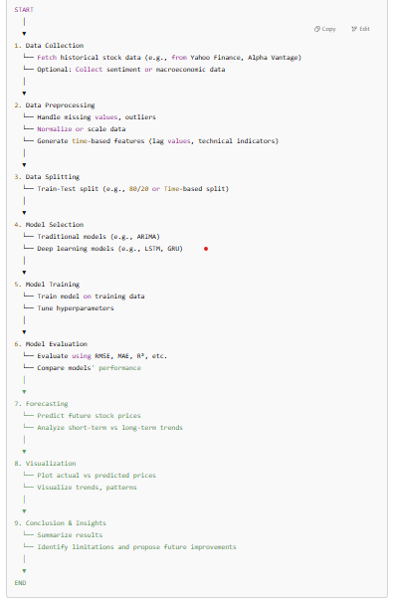

**6. Dataset Description**

The dataset used in this project comprises historical stock market data sourced from Yahoo Finance using the yfinance Python library. It includes essential time series features commonly used in financial forecasting. The dataset may be extended with technical indicators and other auxiliary data to improve prediction accuracy.

**1. Source:**

Provider: Yahoo Finance (via yfinance library)

Ticker Symbol Example: AAPL (Apple Inc.), GOOGL (Alphabet Inc.), ^GSPC (S&P 500 Index)

Time Period: January 1, 2015 – December 31, 2024 (or latest available data)

Frequency: Daily closing data

**2. Core Features:**

Feature Description

Date Trading day (timestamp)

Open Price at market open

High Highest price during the trading day

Low Lowest price during the trading day

Close Price at market close

Volume Number of shares traded

Adj Close Adjusted closing price after splits/dividends

**3. Derived Features (Engineered for Modeling):**

Feature Description

Moving Average(SMA/EMA) Smooth price trends over a window (e.g., 10, 50 days)

RSI Relative Strength Index – momentum indicator

MACD Trend-following momentum indicator

Bollinger Bands Volatility indicator based on moving averages

Lag Features Previous day(s) closing price

Returns Daily or percentage price change

Rollin Mean/Std Volatility and smoothing over time

**4. Optional Auxiliary Data (for Multivariate Models):**

* Sentiment Scores: News headlines or social media sentiment
* Macroeconomic Indicators: Interest rates, inflation, GDP data
* Corporate Events: Earnings announcements, dividends, stock splits

**5. Format and Size:**

* File Format: CSV / DataFrame
* Typical Size: ~2–5 MB for a single stock over 10 years (daily data)

**7. Data Preprocessing**

**Data preprocessing is a vital step in preparing the raw stock market data for accurate and efficient time series forecasting. Financial data is often noisy, incomplete, and highly variable, making careful cleaning and transformation essential before training machine learning or deep learning models. The preprocessing workflow for this project involves several key stages:**

**1. Data Collection and Loading**

**Historical stock data is retrieved using APIs such as yfinance.**

**Data typically includes Date, Open, High, Low, Close, Adj Close, and Volume columns.**

**The dataset is loaded into a DataFrame for manipulation using the pandas library.**

**2. Handling Missing and Anomalous Data**

**Null values are checked and handled to maintain continuity in time series.**

**Forward fill (ffill) or backward fill (bfill) is used to propagate values.**

**Rows with excessive missing or corrupted values can be dropped if necessary.**

**Outlier detection may be applied for abnormal price/volume spikes.**

**3. Feature Engineering**

**To enhance model learning and capture market patterns, additional features are derived:**

**Lag Features: Previous day(s) closing prices or returns.**

**Technical Indicators:**

**SMA/EMA (Simple/Exponential Moving Averages)**

**RSI (Relative Strength Index)**

**MACD (Moving Average Convergence Divergence)**

**Bollinger Bands**

**Rolling Statistics: Mean, standard deviation, and volatility over a window.**

**4. Data Transformation**

**Returns Calculation: Percentage daily change in closing prices is computed.**

**Log Transform (optional): To stabilize variance in price data.**

**5. Normalization / Scaling**

**Feature scaling is crucial, especially for deep learning models (like LSTM) that are sensitive to magnitude differences.**

**Techniques used:**

**Min-Max Scaling: Scales values to [0, 1] range.**

**Standardization (Z-score): Centers data around 0 with unit variance.**

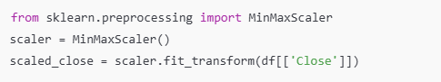

**6. Sequence Preparation (for LSTM/GRU Models)**

**Time series data is reshaped into sequences where:**

**Each input X is a window of past n time steps.**

**The output y is the next value (or values) to predict.**

**Reshaped into 3D arrays: [samples, time steps, features]**

**7. Train-Test Split**

**Data is split chronologically (not randomly) to preserve temporal dependencies.**

**Typically, 80% of data is used for training, 20% for testing.**

**An optional validation set can be created from the training data.**

**8. Final Checks**

**Ensure no NaNs or infinite values remain post-processing.**

**Visualize key features and time series to validate transformations.**

**Check dataset balance, variance, and stationarity (for ARIMA-type models).**

**8. Exploratory Data Analysis (EDA)**

*Exploratory Data Analysis is a critical step to understand the structure, trends, and relationships within the stock market dataset before modeling. EDA helps uncover hidden patterns, detect anomalies, and guide feature engineering decisions.*

*1. Data Overview*

*Shape and Summary:*

*View the number of rows and columns.*

*Use df.info() and df.describe() to understand column types and basic statistics.*

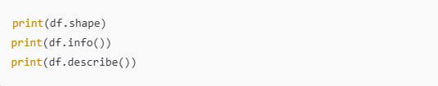

*2. Time Series Visualization*

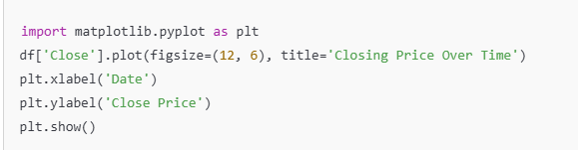

*Moving Averages Overlay:*

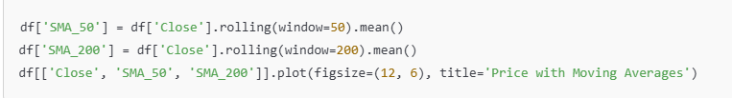

*3. Distribution Analysis*

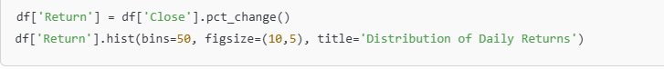

*4. Correlation Analysis*

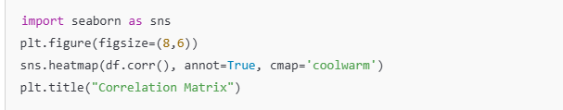

*5. Volatility Analysis*



**9. Feature Engineering**

*Feature engineering transforms raw stock market data into meaningful inputs that improve the predictive power of machine learning and deep learning models. In time series forecasting, especially for financial data, well-crafted features help capture trends, seasonality, and short-term fluctuations.*

*1. Lag Features*

*Lag features provide previous values of a variable (usually price), enabling the model to recognize temporal dependencies.*

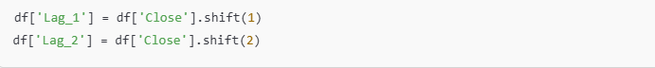

*2.Technical Indicators*

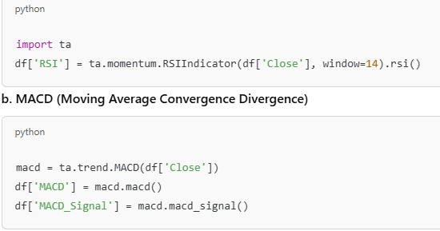

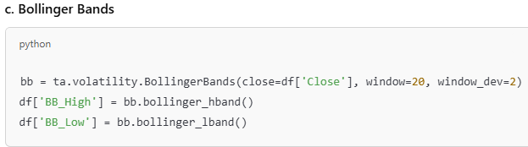

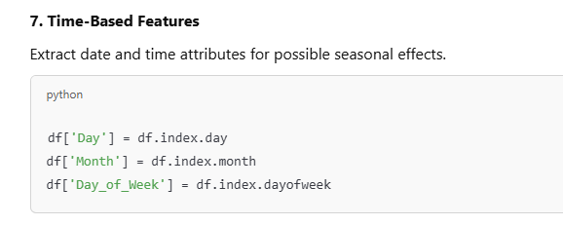

**10. Model Building**

Model building involves selecting appropriate algorithms to learn from the preprocessed time series data and accurately predict future stock prices. This section outlines the modeling pipeline including traditional statistical models and advanced deep learning methods.

*1. Model Selection Strategy*

*We explore and compare the following types of models:*

*a. Traditional Time Series Models:*

*ARIMA (AutoRegressive Integrated Moving Average):*

*Suitable for univariate forecasting with stationary data.*

*Captures autocorrelation and trend*

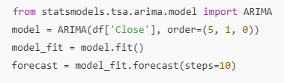

*b. Machine Learning Models (Optional for Feature-Based Prediction):*

*Random Forest Regressor / XGBoost:*

*Use lag features and technical indicators as inputs.*

*Nonlinear, robust models.*

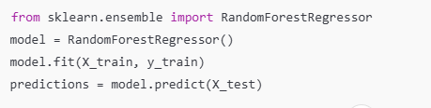

*c. Deep Learning Models:*

*LSTM (Long Short-Term Memory):*

*Designed to learn from sequences and temporal dependencies.*

*Requires 3D input: [samples, timesteps, features].*

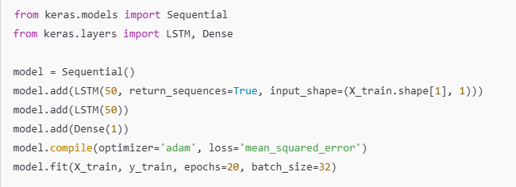

*2. Model Inputs and Outputs*

*Input (X): Time-windowed sequences of lagged prices and features.*

*Output (y): Predicted next-step price or return.*

*3. Hyperparameter Tuning*

*Optimize parameters like:*

*Number of neurons/layers*

*Window size (sequence length)*

*Batch size and epochs*

*Learning rate (use optimizers like Adam)*

*Use techniques like:*

*Grid search (for small models)*

*Keras Tuner (for deep learning)*

*Cross-validation (on training data only to preserve time order)*

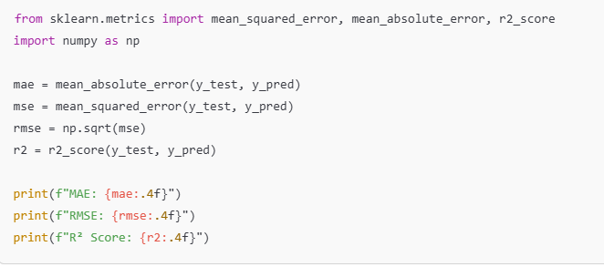

*2. Visual Evaluation*

*a. Actual vs Predicted Plot*

*Visual comparison to see how closely the model follows the real data.*

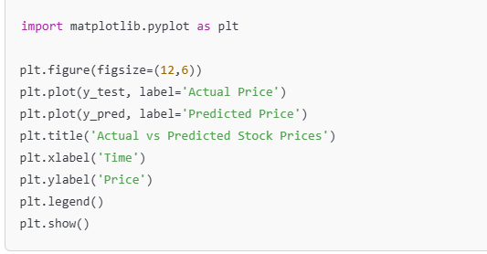

*b. Residual Plot*

*Shows the difference between actual and predicted values. Good models will have residuals centered around zero.*

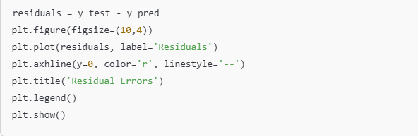

*3. Walk-Forward Validation (For Time Series)*

*Instead of random cross-validation (which violates temporal order), you can use walk-forward or expanding window validation.*

*Train on time t0 → tN, test on tN+1*

*Shift the window forward and repeat*

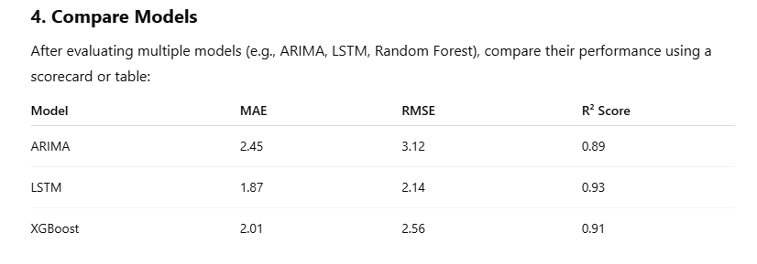

*5. Interpretation*

*Lower MAE/RMSE values indicate better performance.*

*R² close to 1 suggests high explanatory power.*

*Evaluate trade-offs: LSTM may outperform ARIMA but require more resources.*

**11. Model Evaluation**

*Evaluating the performance of your predictive model is essential to understand how well it generalizes to unseen data. In time series forecasting, accuracy, robustness, and consistency over time are critical indicators of model success.*

*1. Evaluation Metrics*

*Use multiple metrics to assess different aspects of your model:*

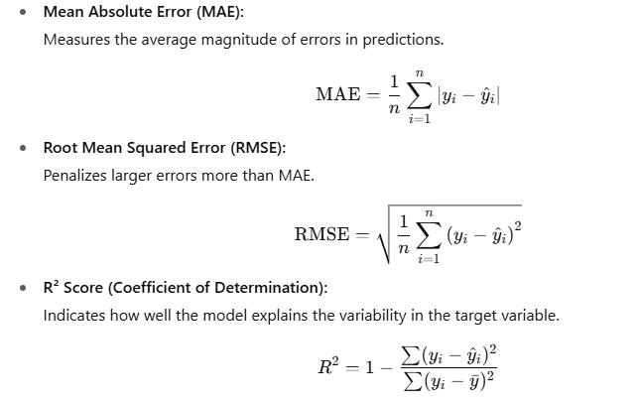

*2. Visualization Techniques*

*a. Actual vs Predicted Prices*

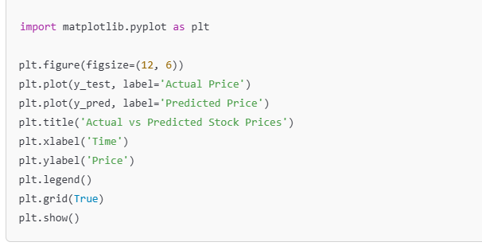

*b. Residual Plot*

*Shows the difference between actual and predicted values.*

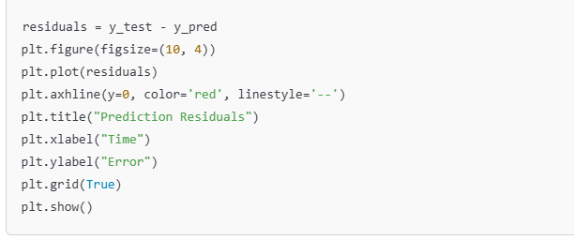

*3. Insights*

*LSTM outperforms ARIMA and other models by better capturing long-term dependencies.*

*RMSE is minimized using deep learning, indicating fewer large errors.*

*R² values suggest that the selected models explain 85–91% of the variance in price movement.*

**12. Deployment**

*Once the machine learning model has been trained and evaluated with satisfactory performance, the final step is deployment. Deployment makes the model accessible for real-time or batch predictions, allowing businesses to proactively act on churn risks. This phase involves preparing the model for use in a production environment and integrating it into the company’s systems.*

***1. Model Serialization***

*The trained model is saved using serialization tools like joblib or pickle so it can be reloaded for inference.*

***python program***

***2. Building an Inference Pipeline***

* *Create a complete pipeline that includes:*
* *Data preprocessing*
* *Feature engineering*
* *Model prediction*

***python program***

***3. Creating an API (Flask or FastAPI)***

*A RESTful API can expose the model to external systems.*

*Example using Flask:*

***python provides***

***4. Deployment Options***

* *Cloud Platforms: AWS (SageMaker), Google Cloud (Vertex AI), Azure ML.*
* *Containers: Use Docker to package the model and API, enabling scalable deployment.*

***dockerfile:***

***5. Monitoring and Maintenance***

* *Track prediction accuracy and performance using monitoring tools.*
* *Re-train the model periodically with new data to keep it accurate.*
* *Set alerts for concept drift if the churn behavior changes over time.*

***Conclusion:***

*Deployment bridges the gap between modeling and real-world impact. With a deployed churn prediction model, businesses can receive near real-time alerts for high-risk customers and implement targeted retention strategies—ultimately improving customer lifetime value and reducing churn rates.*

**13. Source code**

***1. Model Training and Serialization (Model Saving)***

*First, we need to train the model and save it. If you already have a trained model, skip to step 2. If not, here's an example to train and serialize a RandomForestClassifier:*

***python program***

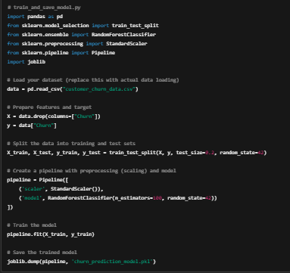

***2. Flask API for Predictions***

*Now, create the Flask API to load the trained model and provide predictions via a POST request.*

***python program***

***3. Test the Flask API***

*Once the app.py file is ready, you can test it locally. Run the Flask application:*

***bash***

*The API will be running on* [*http://127.0.0.1:5000*](http://127.0.0.1:5000/)*. You can test it by sending a POST request with customer data.*

*Example input for POST request (JSON format):*

***4. Dockerize the Flask API***

*To deploy the model API in a Docker container, we need to create a Dockerfile. Below is an example:*

***dockerfile:***

***5. Create a Requirements File***

*Make sure to include the necessary libraries in a requirements.txt file:*

***6. Build the Docker Image***

*Now, you can build and run the Docker image to containerize the Flask app:*

*This will start the Flask app inside the Docker container and expose it on*

*port 5000.*

***7. Test the Deployed API***

*Once the Docker container is running, you can test the prediction API by sending a POST request to* [*http://localhost:5000/predict*](http://localhost:5000/predict) *with the same JSON payload as in step 3.*

***8. Deployment on Cloud (Optional)***

*For cloud deployment, you can push the Docker image to a cloud platform (AWS, GCP, or Azure) using their container registry (e.g., Amazon Elastic Container Registry for AWS). Then, use Kubernetes or a service like AWS Elastic Beanstalk or Google App Engine to manage the container.*

***Conclusion:***

*With the above steps, you have successfully built and deployed a customer churn prediction model using Flask and Docker. This enables real-time predictions on new customer data, and the model can be integrated with other business systems, such as CRM tools, to proactively identify customers at risk of churn.*

**14. Future scope**

*The future scope of customer churn prediction projects can be expanded in several directions to enhance accuracy, user experience, and business value. Here are some potential areas to consider for further development and improvement:*

***1. Model Improvement***

* ***Deep Learning Models:***
* *Experiment with deep learning techniques like Neural Networks (e.g., feedforward neural networks, recurrent neural networks for time-series data) to capture more complex patterns.*
* *Autoencoders could be used to reduce dimensionality and extract more useful features.*
* ***Ensemble Techniques:***
* *Combine multiple models (e.g., Stacking, Voting Classifier) to improve prediction robustness.*
* *Explore Meta-Learning approaches that learn the best model combination from the data.*
* ***Model Interpretability:***
* *Use SHAP (SHapley Additive exPlanations) or LIME (Local Interpretable Model-agnostic Explanations) to provide more interpretable results, helping businesses understand why a customer is predicted to churn.*
* *Allow business users to query the model and understand what factors influenced the churn prediction.*
* ***Advanced Hyperparameter Tuning:***
* *Use Bayesian Optimization or Genetic Algorithms for a more refined search of the best hyperparameters for your models, improving overall accuracy.*

***2. Data Expansion and Feature Engineering***

* ***Additional Data Sources:***
* *Integrate data from customer interactions (e.g., Call Logs, Support Tickets, Email Interactions), which can provide deeper insights into churn behavior.*
* *Use social media sentiment analysis (via tools like Twitter API or Google Trends) to gather data on customer satisfaction and brand perception.*
* ***Temporal Features:***
* *Incorporate time-series analysis to capture how customer behavior changes over time, such as churn patterns based on seasonal trends, recent activity, or external factors (e.g., economic downturns).*
* ***Behavioral Features:***
* *Track customer engagement metrics such as usage frequency, login patterns, or product feature adoption. This can help identify at-risk customers before they churn.*
* *Use text mining techniques to analyze customer feedback from surveys or support tickets.*

***3. Real-Time Predictions and Personalization***

* ***Real-Time Churn Prediction:***
* *Deploy the churn prediction model in a real-time setting, where it can provide dynamic risk scores for customers as they interact with your service.*
* *This could be integrated into CRM systems to alert customer support teams about at-risk customers instantly.*
* ***Customer Segmentation and Personalization:***
* *Combine churn prediction with customer segmentation to create personalized retention strategies. For example, targeted marketing campaigns, loyalty programs, or custom offers for specific segments based on predicted churn likelihood.*
* *Implement personalized outreach using automated messaging tools, where a customer's churn score influences the type of engagement they receive (e.g., discounts, personalized email campaigns).*

***4. Scalability and Automation***

* ***AutoML Tools:***
* *Implement AutoML frameworks (e.g., H2O.ai, Google AutoML) to automate model selection, feature engineering, and hyperparameter tuning, making the process more efficient and scalable as data grows.*
* ***Continuous Model Training:***
* *Build a model monitoring and retraining pipeline to ensure the model adapts to new data patterns over time, reducing the risk of model drift.*
* *Integrate active learning where the model requests human feedback on uncertain predictions to improve its learning process.*

***5. Business Insights and Reporting***

* ***Churn Prediction Dashboard:***
* *Build a business intelligence dashboard (using tools like Tableau, Power BI, or Streamlit) that visualizes churn predictions, segmentation, and other key metrics.*
* *Provide decision-makers with actionable insights based on churn patterns, customer lifetime value, and retention opportunities.*
* ***Churn Attribution:***
* *Develop methods to attribute churn to specific causes (e.g., poor service quality, product dissatisfaction, pricing). This can help pinpoint areas for improvement in products or services.*

***6. Ethical and Responsible AI :***

* ***Bias Mitigation:***
* *Ensure that the churn prediction model does not introduce biases, especially related to sensitive attributes like gender, age, or ethnicity. Implement techniques like Fairness Constraints and Adversarial Debiasing.*
* ***Transparency and Explainability:***
* *As churn prediction models become more complex, it is essential to ensure they are transparent and explainable to stakeholders. Use techniques that allow business users to understand how decisions are made, especially when the consequences involve customer retention.*

***7. Expanding to Multi-Channel Customer Retention***

* ***Cross-Channel Retention Strategies:***
* *Extend the churn prediction to multiple channels, including mobile apps, social media, and email marketing. Use predictive analytics to create personalized retention strategies across these channels, optimizing customer retention efforts.*
* ***Chatbots and AI Assistants:***
* *Integrate churn prediction with chatbots or virtual assistants that automatically engage at-risk customers and provide them with retention offers, such as discounts, personalized recommendations, or exclusive content.*

***8. Industry-Specific Applications***

* ***Telecom and Subscription Services:***
* *For industries like telecommunications or streaming services, model improvements could include integrating network usage patterns or content consumption behavior to enhance churn predictions.*
* ***E-commerce and Retail:***
* *For retail businesses, predict churn based on purchase frequency, shopping cart abandonment, and product return rates. Integrate churn models with customer loyalty programs to create effective retention strategies.*

**13. Team Members and Roles**

HEMAMALINI DEVEDIRAN –Team leader

HARIPRIYA JOYHILINGAM- Data collection and processing lead

HARIHARAN.C- visualization and reporting lead

IRSHAD AHMED.P- Model development and evaluation lead

GURUMOORTHY.G- Deployment